

50 INCH ELECTRIC FIREPLACE WITH REMOTE
Model Numbers: BG-G-01

OWNER’S MANUAL
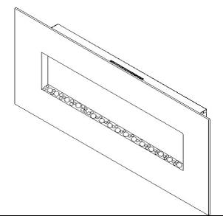

 WARNING | Read and understand this entire owner’s manual, including all safety information, before plugging in or using this product. Failure to do so could result in fire, electric shock, or serious personal injury.

CAUTION | Keep this owner’s manual for future reference. If you sell or give this product away, make sure this manual accompanies this product.

Technical Support: 1-866-206-0888
Service Email: info@mecanair.net

IMPORTANT SAFETY INFORMATION!

 WARNING
- Read all instructions before using this heater!
- This heater is hot when in use. To avoid burns, DO NOT let bare skin touch hot surfaces. If provided, use handles when moving this heater. Keep combustible materials, such as furniture, pillows, bedding, papers, clothes, and curtains at least 3 feet (0.9m) from the front of the heater, and keep them away from the sides and rear.
- Extreme caution is necessary when any heater is used by or near children or invalids and whenever the heater is left operating and unattended.
- DO NOT operate any heater with a damaged cord or plug or after the heater malfunctions, has been dropped or damaged in any manner. Discard heater, or return to authorized service facility for examination and/or repair.
- DO NOT run power cord under carpeting. DO NOT cover power cord with throw rugs, runners, or similar coverings. DO NOT route power cord under furniture or appliances. Arrange power cord away from traffic area, and where it will not be tripped over.
- Connect to properly grounded outlets ONLY.
- DO NOT insert or allow foreign objects to enter any ventilation or exhaust opening, as this may cause electric shock or fire, or damage the heater.
- To prevent a possible fire, DO NOT block air intakes or exhaust in any manner. Doing so could cause a fire. DO NOT use on soft surfaces, like a bed, where openings may become blocked.
- A heater has hot and arcing or sparking parts inside. DO NOT use it in areas where gasoline, paint, or flammable liquids are used or stored.
- Use this heater only as described in this manual. Any other use not recommended by the manufacturer may cause fire, electric shock, or injury to persons.
- ALWAYS plug heaters directly into a wall outlet/receptacle. NEVER use with an extension cord or relocatable power tap (outlet/power strip).
- DO NOT place the heater near a bed because objects such as pillows or blankets can fall off the bed and be ignited by the heater.
- NEVER use this heater in bathrooms, laundry rooms, or any other location where the heater could fall into a bathtub or pool, become damp, or come in contact with water.
- AVOID FIRE! Regularly inspect all air vents to make sure they are free from dust, lint, or other blockage. Unplug the unit and clean with a vacuum ONLY. DO NOT rinse or get wet.
- NEVER hang this unit on a wall directly below an electrical outlet.
- NEVER permanently install in a recessed area of the wall. This may result in blocked air flow, overheating, or fire.
- ALWAYS mount to wall bracket before use. DO NOT set on the floor, or other surface, to use.
- NEVER use a wall mount bracket from another manufacturer.
WARNING
- For residential use only! NOT for commercial use! Any commercial or public use of this heater voids all warranties, and could cause injury.
- This product is not intended to be a primary heat source. It is for supplemental heat only.
- INDOOR use only! NEVER use this heater outdoors! Doing so may result in electric shock!
- Risk of electric shock! DO NOT OPEN! No user-serviceable parts inside!
- NEVER modify this heater. Doing so could result in personal injury or property damage. Modification of this fireplace completely voids all warranties.
- ALWAYS turn this heater off before unplugging it from the outlet.
- ALWAYS disconnect this unit from the power supply before performing any assembly or cleaning, or before relocating the electric fireplace.
- NEVER leave this heater unattended. ALWAYS unplug this heater when not in use.
- ALWAYS store this heater in a dry location. NEVER use the fireplace if it has become wet.
- ONLY use this heater on a 120 Volt 15 Amp grounded circuit. NEVER overload the circuit. If this heater trips the circuit breaker, unplug all other appliances on the same circuit before the next use. Avoid plugging other appliances into the same circuit as this heater.
- NEVER plug this heater into an outlet that is old, cracked, or has any loose wires or connections. Plugging this heater into a faulty outlet could result in electric arcing within the outlet that could cause the outlet to overheat or catch fire.
- ALWAYS check your heater cord and plug connections with each use!
- MAKE SURE the plug fits tight in the outlet! Faulty wall outlet connections or loose plugs can cause the outlet to overheat.
- Heaters draw more current than small appliances. Overheating may occur even if it has not occurred with the use of other appliances.
- During use check frequently to see if the plug outlet or faceplate is HOT!
iv) If the outlet or faceplate is HOT, discontinue use immediately and have a qualified electrician inspect and/or replace the faulty outlets.
SAVE THESE INSTRUCTIONS

Preparation

 | This product includes a GLASS panel! Always use extreme caution when handling glass. Failure to do so could result in personal injury or property damage.
Remove all parts and hardware from the carton and place them on a clean, soft, dry surface. Check the parts list to make sure nothing is missing. Dispose of packaging materials properly. Please recycle whenever possible.
You will need the following tools (not included): Phillips screwdriver; stud finder; level; tape measure; electric drill; 1/4” wood drill bit, hammer.

Parts and Hardware

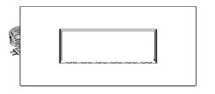  A – Fireplace ( 1 ) | 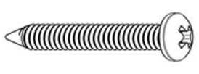 | 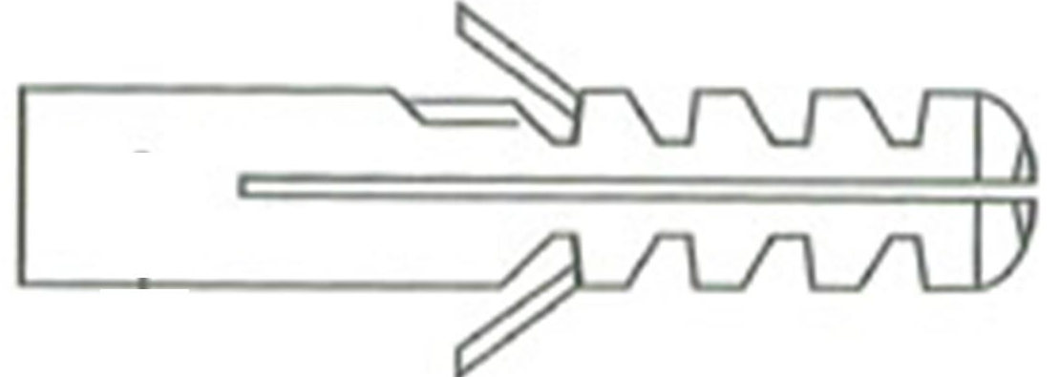
 | B – Wood Screws ( 5 sets ) | C – Drywall anchors ( 5 )
 | 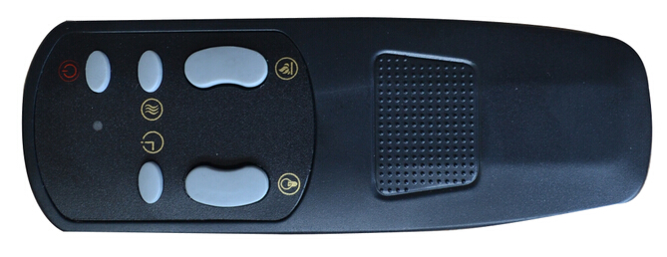
 | RC – Remote Control

F-- Decorative pebbles

Installation and Assembly
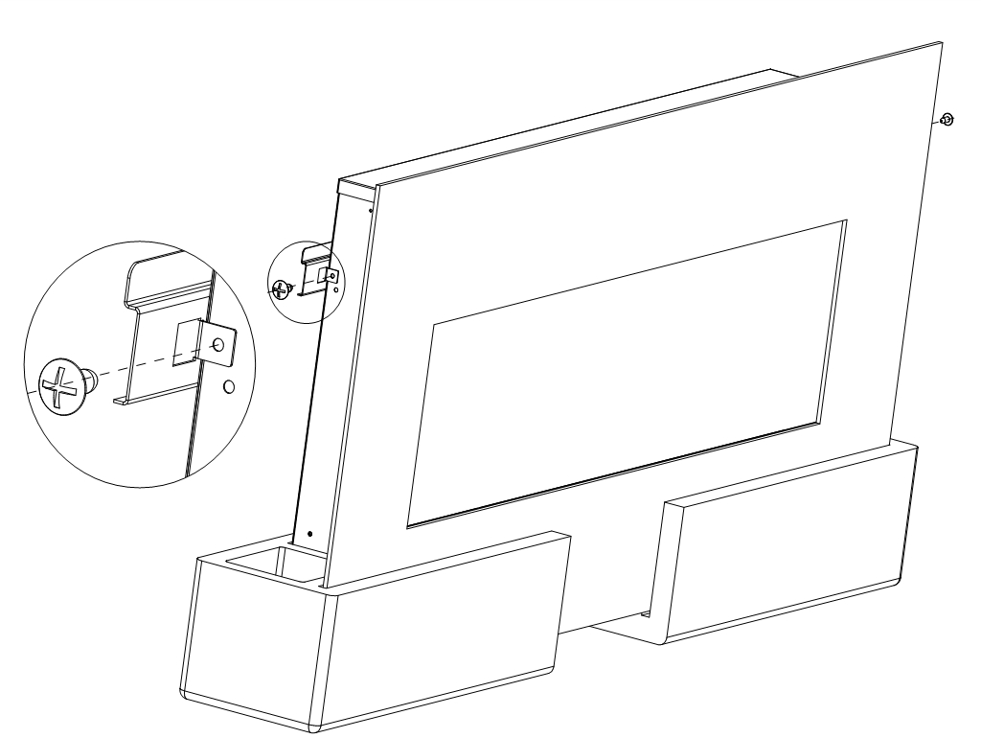
Note: This must be done by at least 2 people.

- Take out the firebox from the package, and put it on the flat surface
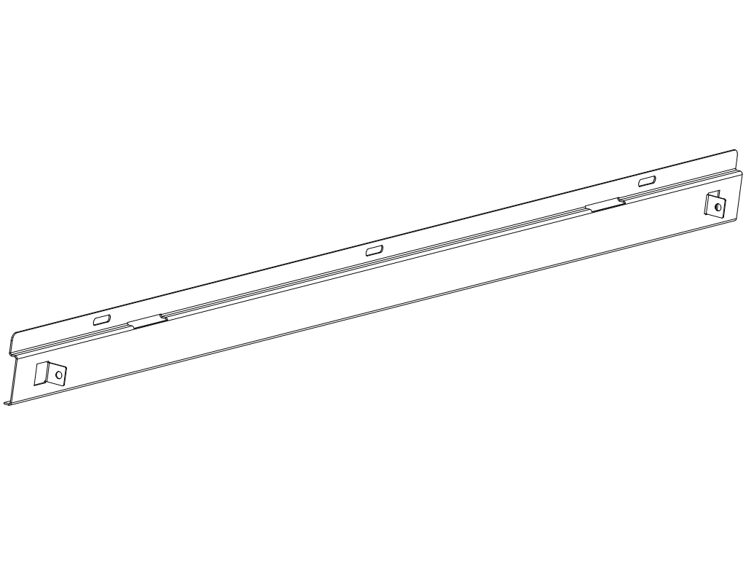
- Take off the screws at the two sides with Phillips screwdriver, then take off the wall bracket (You must hold the brackets before taking off the screws, in order to avoid a falling damage to the floor and machine.

Rear View of Fireplace  Minimum 39.4” (100 cm)  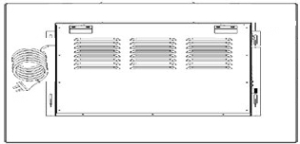  19.7” (50 cm)  19.7” (50 cm)  Minimum 19.7” (50 cm) | Step 1. Find a safe location.  Minimum clearance on each side: 19.7” (50 cm).  Minimum clearance below: 19.7” (50 cm).  Minimum clearance above: 39.4” (100 cm).  Minimum clearance from the front and sides: 3 feet (90 cm).  Choose a location near an outlet so an extension cord is not required.  DO NOT position the unit directly below a power outlet.  See Safety Information on pages 2 and 3 for warnings about safe placement, safe installation, and proper use of this product.

NOTICE | The wall mount fasteners included with this fireplace are for use ONLY with a wood-framed wall covered in drywall (sheet rock). For concrete walls, cinder blocks, or other wall types, consult a professional for the best attachment methods.

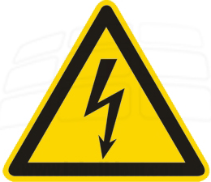 | ALWAYS unplug this fireplace heater before assembly or cleaning, or before relocating. Failure to do so could result in electric shock, fire, or personal injury.

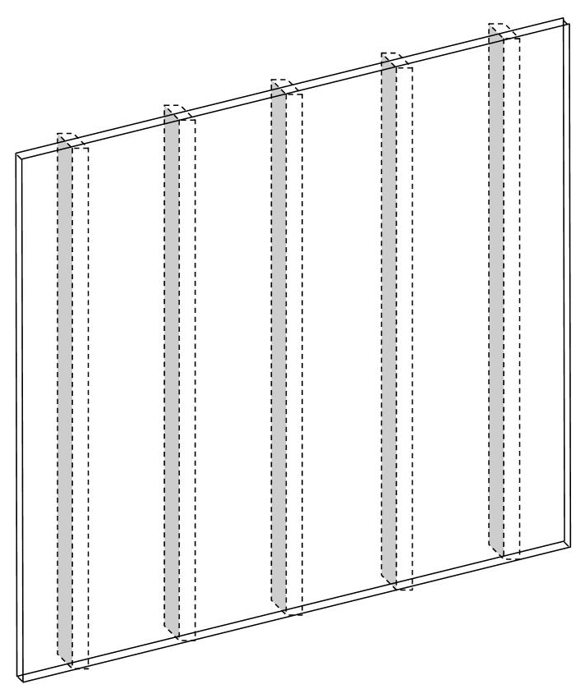  Drywall  Studs | 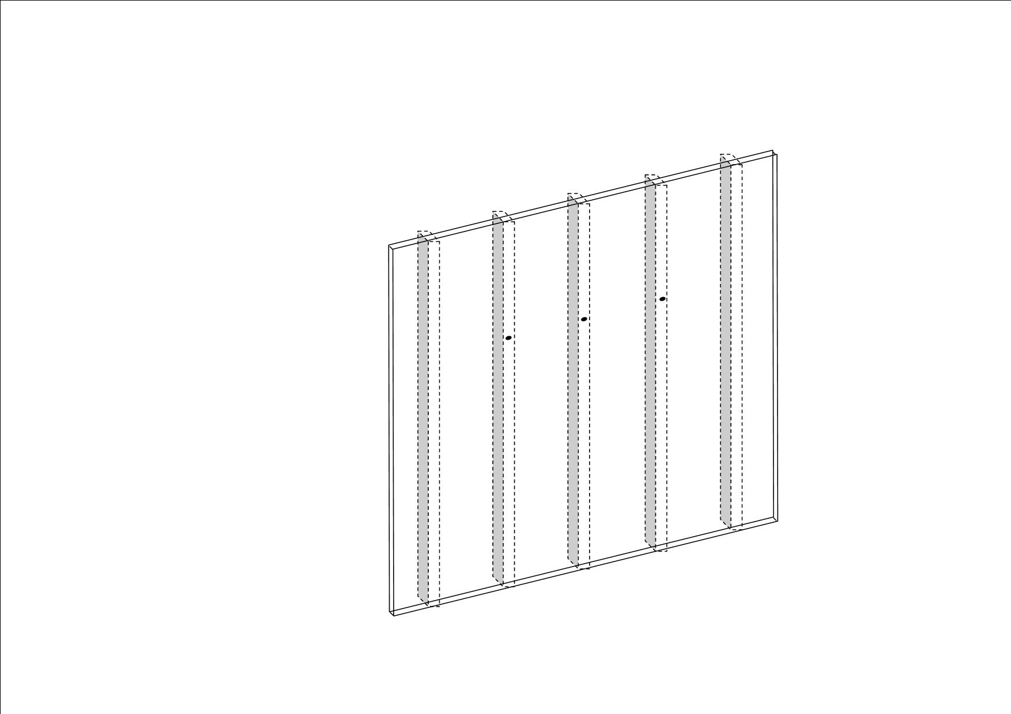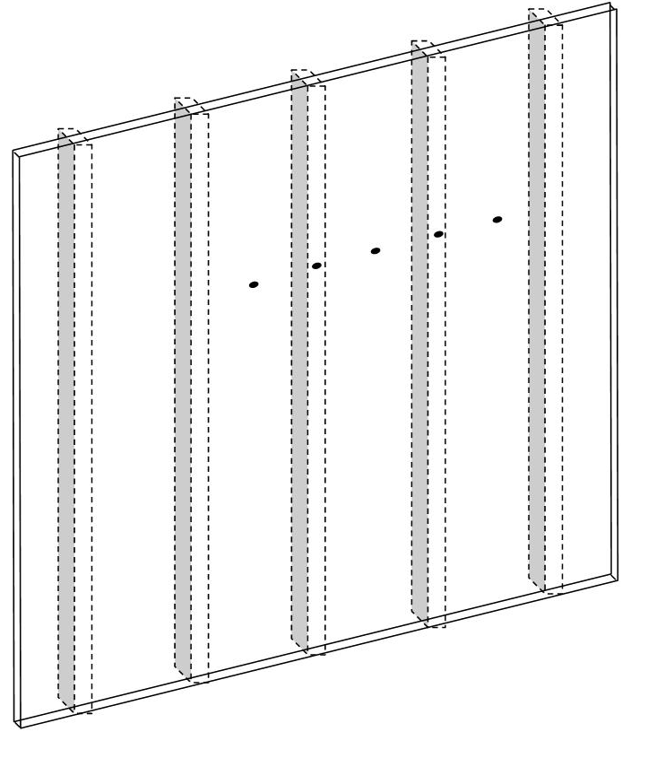
STEP 2. A. Locate the wall studs using an electronic stud-finder. Mark the hole locations with a pencil. The holes should be 8” (20.3 cm) apart, and level. The minimum height from the surface below must be 19.7” (50 cm). B. Three screws should be screwed directly into wall studs. Then, no drywall anchors are needed. C. If only two studs are available, two screws MUST be screwed directly into studs, and the other screws must be screwed into the drywall anchors.

AVOID INJURY and DAMAGE! Three screws should be screwed directly into wall studs. If only two studs are available, two screws must be screwed directly into the wall studs, and additional screws must also be screwed into the drywall anchors.

Mounting into three wall studs Mounting into two wall studs and drywall anchors
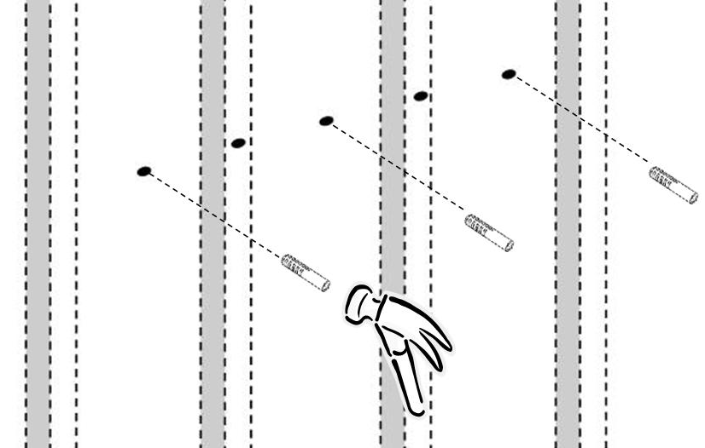
C
C
C
STEP 3. Drill a pilot hole into each mark using a 1/4” wood drill bit. A. If screws will go into three studs, no drywall anchors are needed. B. Tap the drywall anchor(s) (C) carefully into the drywall holes until they are flush with the drywall surface. Use care to avoid damage.

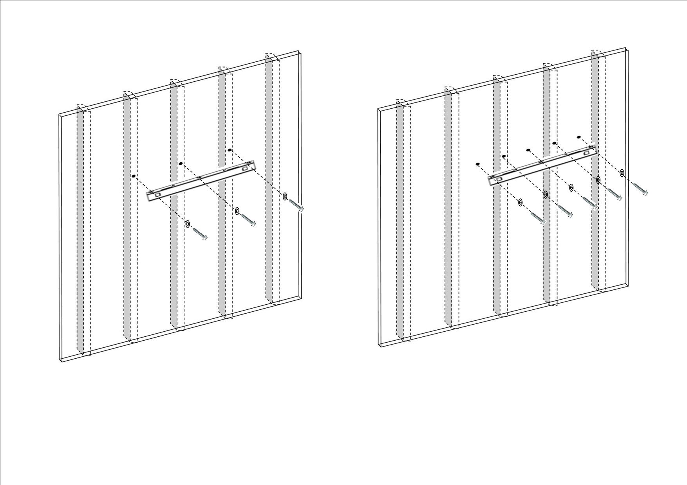
B
B
B
B
B
B
E
E
B
B

STEP 4. Align the holes in the wall bracket (E) with the pilot holes and drywall anchors. Thread wood screws (B) through washers and holes in the wall bracket, then directly into the wall studs and/or drywall anchors. Make sure bracket is level. Tighten all screws securely with a screwdriver.

ALWAYS unplug this fireplace heater before assembly or cleaning, or before relocating. Failure to do so could result in electric shock, fire, or personal injury.

A | 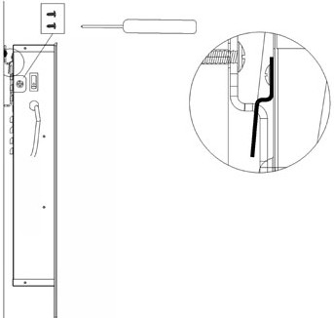  A  E  D
STEP 5. A. With the help of a capable adult, lift the fireplace (A) and align the hooks on the back of the fireplace with the slots on the wall bracket. Carefully set the hooks into the slots.
B. Secure the fireplace to the wall bracket with two ST4x8 metal screws (D), one on each side. Thread the screws through the fireplace and into the wall bracket side tabs. Tighten both screws with a Phillips screwdriver. The unit may now be plugged in.

This next step involves GLASS! ALWAYS use extreme caution when handling glass. Failure to do so could result in personal injury or property damage.

NOTE: This part explains the installation of the decorated glass pebbles in the fireplace. ALWAYS keep the decorative glass OUT OF REACH OF CHILDREN! Leave no glass where children can find them. Failure to do so could cause a choking hazard.

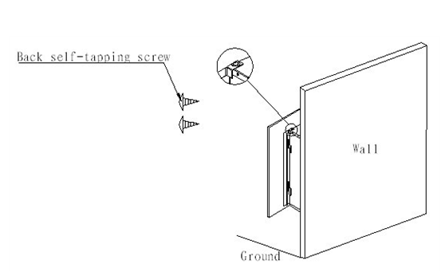
Glass
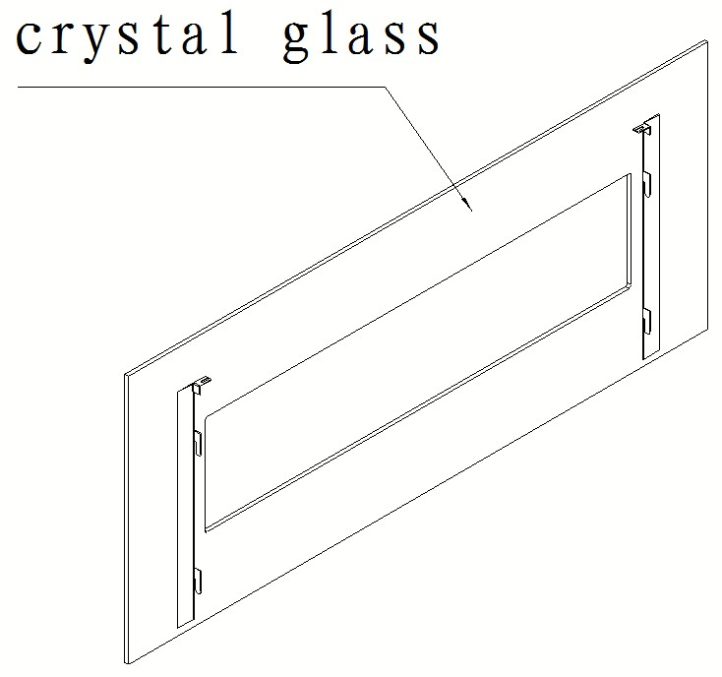

A

B

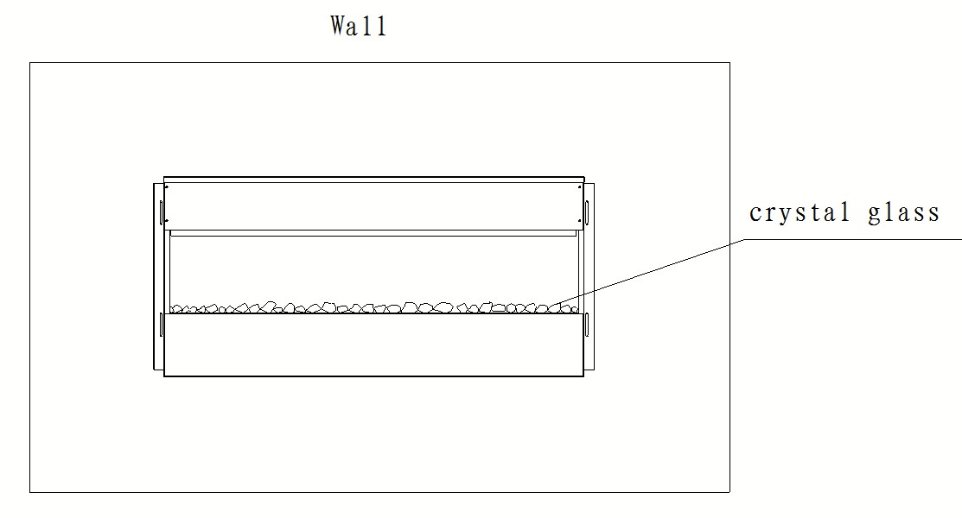

Pebbles

C

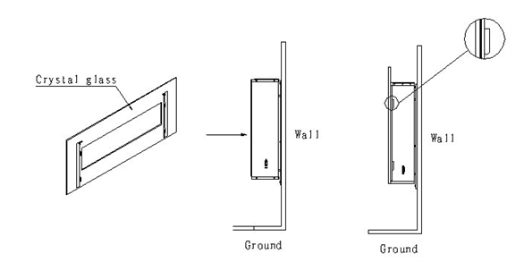

D
Glass

NOTE: We recommend that two capable adult perform this procedure.
STEP 6A. With you or someone holding the glass panel, remove the two screws at the top edge of the fireplace with a Phillips (+) screwdriver.
STEP 6B. Together, carefully remove the front glass panel and set it aside on a clean soft surface.
STEP 6C. Place the decorative pebbles (F) on the fireplace ledge in any desired position.
STEP 6D. Align the tabs of the glass panel with the holes on the top edge of the fireplace. Thread the screws back into the holes and tighten them both with a Phillips screwdriver.

Operation

Read and understand this entire owner’s manual, including all safety information, before plugging in or using this product. Failure to do so could result in electric shock, fire, serious injury or death.
Power
Make sure the ON/OFF switch, located on the left side panel, is in the OFF position. Plug the power cord into a 120 Volt 15 Amp grounded outlet (see IMPORTANT SAFETY INFORMATION on Pages 2 and 3). Make sure the outlet is in good condition and that the plug is not loose. NEVER exceed the maximum amperage for the circuit. DO NOT plug other appliances into the same circuit.
Methods of Operation
This electric fireplace can be operated by the CONTROL PANEL, located on the left side panel of the fireplace (see figure below), or by the battery-powered REMOTE CONTROL.
The operation and functions of the two methods are the same.
Before operating, please review the IMPORTANT SAFETY INFORMATION on Pages 2 and 3, and heed all warnings.
NOTICE | When the heater is first turned on, a slight odor may be present. This is normal and should not occur again unless the heater is not used for a long period of time.

Front View  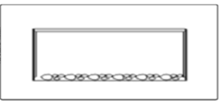 | Top View  Hot Air Vents  \  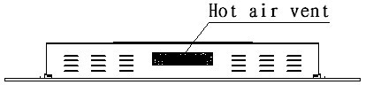

Rear View | Left Side View  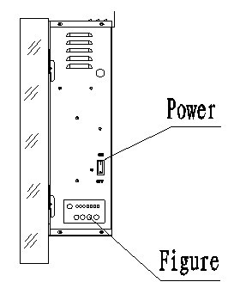
Control Panel Operation
BUTTON | FUNCTION | ACTION & INDICATION
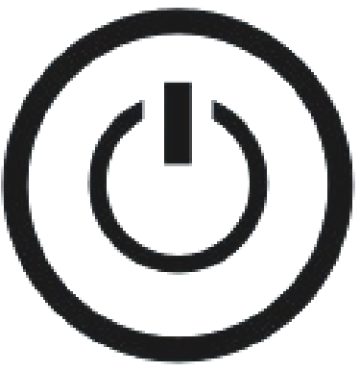  POWER | ON: Enables touch panel functions and remote control. Turns on flame effect.  OFF: Disables touch panel functions and remote control. Turns off flame effect. | 1. Press once. Indicator light turns on. Power turns on. All functions enabled.  2. Press again. Flame effect turns off. Unit goes to standby. All functions turn off.
  TIMER | TIMER button: Controls timer settings to turn off fireplace at selected time.  Settings range from 0.5 hours to 7.5 hours. | 1. Press once. Indicator light turns on. Timer is set to 0.5 hours.  2. Press again until desired setting is reached. Indicator lights show setting.
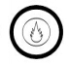  FLAME  FLAME - | FLAME button: Makes flame effect dimmer and brighter.  NOTE: Flame effect stays on until power button is turned off. Flame effect must be on for heater to turn on. | 1. Press once. Flame brightness effect gets changing.  2. Press again until desired setting is reached.
  COLOR  FLAME + | COLOR button: Makes the color flame effect changing.  NOTE: color effect stays on until power button is turned off. Color flame effect must be on for heater to turn on. | - Press once. Flame color effect gets changing.  - Press again until desired setting is reached. Total 10 colors.
  HEATER | HEATER button: Turns heater on and off.  NOTE: The heater only works when the flame effect is on. If the flame effect is off, the heater will not turn on.  NOTE: To prevent overheating, the heater fan will blow cool air for 8-10 seconds before the heater turns on, and after the heater turns off. | 1. Press once. Indicator lights up.  Fan blows cool air for 10 seconds. 750W heater turns on and blows warm air.  2. Press again. Indicator lights up.  1500W heater turns on and blows hot air.  3. Press again. Heaters turn off.  The fan blows cool air for 10 seconds to allow heater to cool down, then turns off.

NOTICE | To improve operation, aim the remote control at the remote receiver, and DO NOT press the buttons too quickly. Give the unit time to respond to each command.

Remote Control (Control panel POWER switch must be ON to use remote control.)

BUTTON | ACTION and INDICATION | CONTROL PANEL
POWER | 1. Press once. Beep. Flame effect and indicator turn on.  2. Press again. Beep. Power and all functions turn off. | 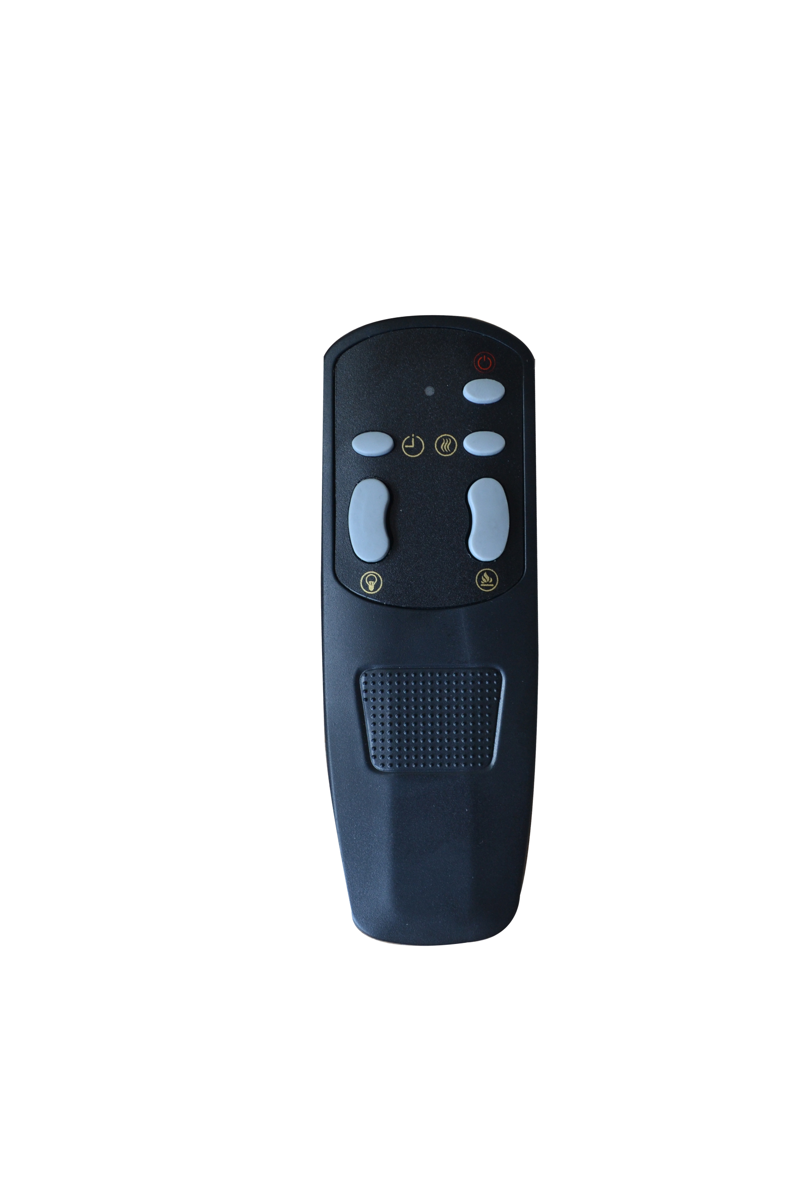
HEATER | 1. Press once. Small indicator lights up. Fan blows cool air. 750W heater turns on and blows warm air.  2. Press again. Large indicator lights up. 1500W heater turns on and blows hot air.  3. Press again. Heaters turn off. Fan blows cool air to allow heater to cool down, then turns off.
FLAME | 1. Press once. Flame brightness effect gets changing.  2. Press again until desired setting is reached.
COLOR | - Press once. Flame color effect gets changing.  - Press again until desired setting is reached. Total 10 colors.
TIMER | 1. Press once. ½ h light turns on. Timer is set to ½ hour.  2. Press again. 1h light turns on. Timer is set to 1 hour.  3. Press until desired setting is reached. Timer setting increases by ½ hour up to 7½ h.  Examples: 3 hours = 2h+1h; 7½ hours = 4h+2h+1h+½h.  4. Press again. Timer setting increases by ½ hour until desired setting is reached, or until timer turns off.  5. Press again to restart timer from ½h.

NOTICE | To improve operation, aim the remote control at the front of the fireplace. DO NOT press the buttons too quickly. Give the unit time to respond to each command.
Temperature Limiting Control
This heater is equipped with a Temperature Limiting Control. Should the heater reach an unsafe temperature (212°F / 100°C), the heater will automatically turn OFF. To reset:
  - Unplug the power cord from the outlet.
  - Turn the ON/OFF switch on the CONTROL PANEL to OFF. Wait 5 minutes.
  - Inspect the fireplace to make sure no vents are blocked, or clogged with dust or lint. If they are, use a vacuum to clean the vent areas.
  - With the POWER switch in the OFF position, plug the power cord back into the outlet.
  - If the problem continues, have your outlet and wiring inspected by a professional.
Remote Control Battery Information
- This remote control uses two AAA battery (Not included).
- Instructions for battery installation are on the Remote Control battery compartment.

NEVER dispose of batteries in ﬁre. Failure to observe this precaution may result in an explosion. Dispose of batteries at your local hazardous material processing center.

Care and Maintenance

Cleaning
ALWAYS turn the heater OFF and unplug the power cord from the outlet before cleaning, performing maintenance, or moving this fireplace. Failure to do so could result in electric shock, fire or personal injury.
NEVER immerse in water or spray with water. Doing so could result in electric shock, fire, or personal injury.

Metal:
- Buff using a soft cloth, slightly dampened with a citrus oil-based product.
- DO NOT use brass polish or household cleaners as these products will damage the metal trim.
Glass:
- Use a good quality glass cleaner sprayed onto the cloth or towel. Dry thoroughly with a paper towel or lint-free cloth.
- NEVER use abrasive cleansers, liquid sprays, or any cleaner that could scratch the surface.
Vents:
- Use a vacuum or duster to remove dust and dirt from the heater and vent areas.

Plastic:
- Wipe gently with a slightly damp cloth and a mild solution of dish soap and warm water.
- NEVER use abrasive cleansers, liquid sprays, or any cleaner that could scratch the surface.
Maintenance
Risk of electric shock! DO NOT OPEN any panels other than the bulb replacement plate! No user-serviceable parts inside!
ALWAYS turn the heater OFF and unplug the power cord from the outlet before cleaning, performing maintenance, or moving this fireplace. Failure to do so could result in electric shock, fire, or personal injury.
Electrical and Moving Parts:
- The fan motors are lubricated at the factory and will not require lubrication.
- Electrical components are integrated in the fireplace and are not serviceable by the consumer.
Storage:
Store heater in a clean dry place when not in use.

FOYER ÉLECTRIQUE 50 PO AVEC TÉLÉCOMMANDE
No. modèle : BG-G-01

GUIDE DE L’UTILISATEUR

AVERTISSEMENT | Veuillez lire et comprendre ce guide en entier, incluant les informations relatives à la sécurité avant de brancher ou d’utiliser cet appareil. Le non-respect de cette directive peut entraîner un incendie, un choc électrique ou des blessures graves.

ATTENTION | Veuillez conserver ce guide pour référence ultérieure. Si vous revendez ou donnez cet appareil, veillez à fournir ce guide d’utilisateur avec l’appareil.

Soutien technique: 1-866-206-0888
Courriel de service: info@mecanair.net

INFORMATIONS DE SÉCURITÉ IMPORTANTES!

AVERTISSEMENT
Lire toutes les instructions avant d’utiliser le foyer électrique.
- Cet appareil est chaud lorsqu'il est en marche. Pour éviter des brûlures, ne pas laisser la peau toucher aux surfaces chaudes. Utiliser la poignée pour le déplacer. Garder les matériaux inflammables, tels que meubles, oreillers, literie, papier, vêtements et rideaux au moins 3 pieds (0,9 m) du devant de l’appareil et éloignés des côtés et de l'arrière de l'appareil.
- Une prudence et une surveillance adéquates sont nécessaires si la chaufferette est utilisée par ou près des enfants ou des invalides ou lorsqu'elle est utilisée sans surveillance.
- Ne pas utiliser l'appareil si le cordon ou la fiche est endommagé, s’il ne fonctionne pas convenablement ou s’il a été échappé ou endommagé de quelque façon que ce soit. Le cas échéant, arrêter de l’utiliser et l'emmener à un centre de service autorisé pour inspection, réglage électrique ou mécanique ou réparation.
- Ne pas faire passer le cordon électrique sous le tapis. Ne pas couvrir avec des carpettes, tapis de passage ou articles semblables. Éloigner le cordon des endroits passants où les gens pourraient trébucher sur le cordon.
- Brancher l’appareil à une prise murale avec mise à la terre seulement.
- Ne pas insérer ou laisser des objets étrangers pénétrer dans les ouvertures de ventilation ou d’échappement car ceci pourrait causer un choc électrique, un incendie ou des dommages à l’appareil.
- Pour prévenir toute possibilité d’incendie, ne pas bloquer les entrées d’air ou ouvertures d’échappement de quelque manière que ce soit. Ne pas utiliser sur des surfaces molles, telles qu’un lit, car les ouvertures pourraient être bloquées.
- Des pièces chaudes projetant des étincelles se trouvent à l’intérieur du foyer électrique. Ne pas l’utiliser dans des endroits où de l’essence, de la peinture ou des liquides inflammables sont utilisés ou entreposés.
- Utiliser cet appareil seulement tel que décrit dans ce manuel. Toute autre utilisation non recommandée par le fabricant peut causer un incendie, un choc électrique, des blessures corporelles ou de dommages matériels.
- Toujours brancher le foyer électrique directement dans la prise murale. Ne JAMAIS utiliser de rallonge électrique ou de barre d’alimentation multiprises.
- NE PAS PLACER l’appareil près d’un lit car des objets tels qu’oreillers ou couvertures pourraient tomber du lit et être enflammés par l’appareil.
- NE JAMAIS utiliser cet appareil dans les salles de bains, buanderies ou tout autre endroit humide où l’appareil pourrait tomber dans un bain ou un autre réservoir d’eau, devenir mouillé ou entrer en contact avec de l’eau.
- ÉVITEZ LES RISQUES D’INCENDIE! Inspecter régulièrement les ouvertures de ventilation afin de vérifier qu’ils sont exempts de poussière, de mousse ou toute autre matériau pouvant entraîner un blocage. Débrancher l’appareil et le nettoyer avec un aspirateur SEULEMENT. Ne pas rincer l’appareil ni le mouiller.
- NE JAMAIS suspendre cet appareil au mur directement sous une prise électrique murale.
- NE JAMAIS INSTALLER de manière permanente dans un espace en retrait dans le mur. Ce type d’installation peut bloquer la circulation d’air et ainsi entraîner une surchauffe et un risque d’incendie.
- TOUJOURS installer l’appareil sur le support mural avant de l’utiliser. NE PAS le déposer sur le sol ou toute autre surface avant de l’utiliser.
- NE JAMAIS utiliser un support mural provenant d’un autre fabricant.
AVERTISSEMENT
- Usage résidentiel seulement. NON DESTINÉ à un usage commercial! Toute utilisation dans un contexte commercial ou public annulera toutes les garanties et pourrait causer des risques de blessures.
- Cet appareil n’est pas conçu pour être une source principale de chauffage. Il doit servir comme source supplémentaire de chauffage seulement.
- USAGE À L’INTÉRIEUR seulement! NE JAMAIS utiliser cet appareil à l’extérieur; risque de choc électrique!
- Risque de choc électrique! NE PAS OUVRIR! Aucune pièce réparable par l’utilisateur à l’intérieur.
- NE JAMAIS modifier cet appareil. Le non-respect de cette directive peut entraîner des blessures personnelles ou des dommages matériels. Toute modification apportée au foyer électrique entraînera l’annulation de toutes les garanties.
- TOUJOURS arrêter l’appareil avant de le débrancher de la prise électrique.
- TOUJOURS débrancher cet appareil de l’alimentation électrique avant d’effectuer tout assemblage ou nettoyage, ou de déplacer le foyer électrique.
- NE JAMAIS laisser l’appareil sans surveillance. TOUJOURS débrancher l’appareil lorsqu’il n’est pas utilisé.
- TOUJOURS ranger l’appareil dans un endroit sec. NE JAMAIS utiliser le foyer électrique s’il est mouillé.
- Brancher uniquement l’appareil à un circuit de 120 Volts, 15 A avec mise à la terre. NE JAMAIS surcharger le circuit. Si l’appareil déclenche le disjoncteur relié au circuit, débrancher tous les autres appareils branchés au même circuit avant de réutiliser l’appareil. Évitez de brancher d’autres appareils sur le même circuit que le foyer électrique.
- NE JAMAIS brancher cet appareil dans une prise électrique usée, fissurée, ou qui a des fils lâches. Le fait de brancher l’appareil a une prise défectueuse peut entraîner la production d’arcs électriques dans la prise, ce qui peut causer une surchauffe ou même un incendie.
- TOUJOURS vérifier le branchement de l’appareil avant chaque utilisation!
- VÉRIFIEZ que la fiche est insérée à fond dans la prise! Une fiche mal insérée ou une prise défectueuse peut entraîner une surchauffe à la prise.
- Les appareils de chauffage consomment plus de courant que les autres appareils électriques. Une surchauffe peut survenir même si cela ne s’est pas produit avec d’autres appareils.
- Durant l’utilisation, vérifiez fréquemment si la fiche ou la prise électrique est CHAUDE!
- Si la prise est chaude, arrêter immédiatement l’appareil et demandez à un électricien d’inspecter et de remplacer les prises défectueuses, le cas échéant.
CONSERVEZ CES INSTRUCTIONS

Préparation

Ce produit est doté d’un panneau de verre. Faites toujours preuve d’une grande précaution lors de la manipulation du verre. Le non-respect de cette directive peut entraîner des blessures personnelles et des dommages matériels.
Retirez toutes les composantes et la quincaillerie de la boîte et placez-les sur une surface propre et sèche. Vérifiez la liste des pièces pour vous assurer qu’aucune pièce n’est manquante. Recyclez les matériaux d’emballage dans la mesure du possible.
Vous aurez besoin des outils suivants (non inclus) : tournevis cruciforme, détecteur de montants, niveau; ruban à mesurer, perceuse électrique, foret ¼ po pour le bois, marteau.

Pièces et quincaillerie

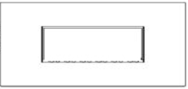
A – Foyer (1)
 | B – Vis à bois (5 ens.) | C – Chevilles pour cloisons sèches (5)
 |  | RC – Télécommande
F Galets décoratifs

Installation et assemblage

Remarque : Cette étape doit être effectuée à l’aide de deux personnes ou plus.

- Retirez le corps du foyer de la boîte et placez-le sur une surface plate.
- Retirez les vis sur les deux côtés à l’aide du tournevis cruciforme, puis retirez le support (vous devez retenir le support avant de retirer les vis, afin d’éviter que le support ne tombe et endommage l’appareil ou le sol).

Vue arrière du foyer  Minimum 39,4po (100 cm)  19,7 po (50 cm)  19.7po (50 cm)  Minimum 19,7po (50 cm) | Étape 1. Trouvez un emplacement sûr.  Espace minimum de chaque côté : 19,7 po (50 cm).  Espace minimum en-dessous : 19,7 po (50 cm).  Espace minimum au-dessus : 39,4 po (100 cm).  Espace libre minimum à l’avant et sur les côtés : 3 pi (90 cm).  Choisissez un endroit près d’une prise électrique. Vous ne devez pas utiliser de rallonge avec cet appareil.  NE PAS PLACER l’appareil directement sous une prise électrique murale.  Consultez les informations de sécurité aux pages 13 et 14 pour le placement, l’installation et Espace minimum du produit en toute sécurité.

NOTE | Les supports muraux inclus avec le foyer électrique doivent SEULEMENT être utilisés dans un mur de placoplâtre avec montants de bois. Pour les murs de béton, les blocs de maçonnerie ou tout autre type de surface, contactez un professionnel pour déterminer le type de fixation à utiliser.

TOUJOURS débrancher l’appareil avant l’assemblage ou le nettoyage, ou avant de le déplacer. Le non-respect de cette consigne entraînera un choc électrique, un incendie ou des blessures graves.

Mur
Montants
ÉTAPE 2. A. Trouvez les montants à l’aide d’un détecteur électronique. Marquez l’emplacement des trous au crayon. Les trous devraient être espacés de 8 po (20,3 cm) et droits; la hauteur minimale à partir du sol est de 19,7 po (50 cm). B. Si les trois vis peuvent être posées dans les montants, les chevilles d’ancrage ne sont pas requises. C. Si seulement deux montants sont disponibles, deux vis DOIVENT être posées directement dans les montants et les autres vis doivent être posées avec les chevilles d’ancrage.

ÉVITEZ LES BLESSURES ET LES DOMMAGES! Trois vis devraient être serrées directement dans les montants. Si seulement deux montants sont disponibles, deux vis DOIVENT être posées directement dans les montants et les autres vis doivent être posées avec les chevilles d’ancrage.

Pose dans trois montants Pose dans deux montants avec chevilles d’ancrage
C
C
C
ÉTAPE 3. Percez un avant-trou à chaque emplacement, à l’aide d’un foret ¼ po pour le bois. A. Si les trois vis sont posées dans les montants, les chevilles d’ancrage ne sont pas requises. B. Tapez doucement les chevilles d’ancrage (si requis) dans les trous jusqu’à ce qu’ils soient à niveau avec la cloison sèche. Faites attention de ne pas endommager la surface.

B
B
B
B
B
B
E
E
B
B

ÉTAPE 4. Alignez les trous du support mural (E) et les trous au mur. Serrez les vis à bois (B) dans les rondelles et les trous du support mural, puis dans les montants et/ou les chevilles d’ancrage. Vérifiez que le support est parfaitement droit. Serrez toutes les vis à fond à l’aide d’un tournevis.

TOUJOURS débrancher l’appareil avant l’assemblage ou le nettoyage, ou avant de le déplacer. Le non-respect de cette consigne entraînera un choc électrique, un incendie ou des blessures graves.

A | A  E  D
ÉTAPE 5. A. Avec l’aide d’une autre personne, soulevez le foyer (A) et alignez les crochets à l’arrière du foyer avec les fentes dans le support mural. Faites glisser les crochets avec précaution dans les fentes.
B. Fixez le foyer solidement au mur à l’aide de deux vis à métaux ST4x8 (D), soit une vis de chaque côté. Faites passer les vis dans le foyer, puis dans les languettes de chaque côté du support mural. Serrez les vis à fond à l’aide d’un tournevis cruciforme. L’appareil peut maintenant être branché.

La prochaine étape utilise le verre. Faites TOUJOURS preuve de précaution extrême lors de la manipulation du verre. Le non-respect de cette directive peut entraîner des blessures personnelles ou des dommages matériels.

NOTE : Cette partie explique l’installation des galets décoratifs en verre. TOUJOURS garder les galets décoratifs hors de portée des enfants! Ne laissez pas les galets à un endroit où les enfants ont accès. Les galets décoratifs présentent un danger d’étouffement.

Galets
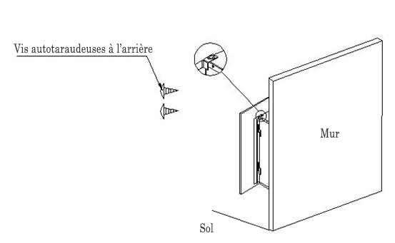
A

B

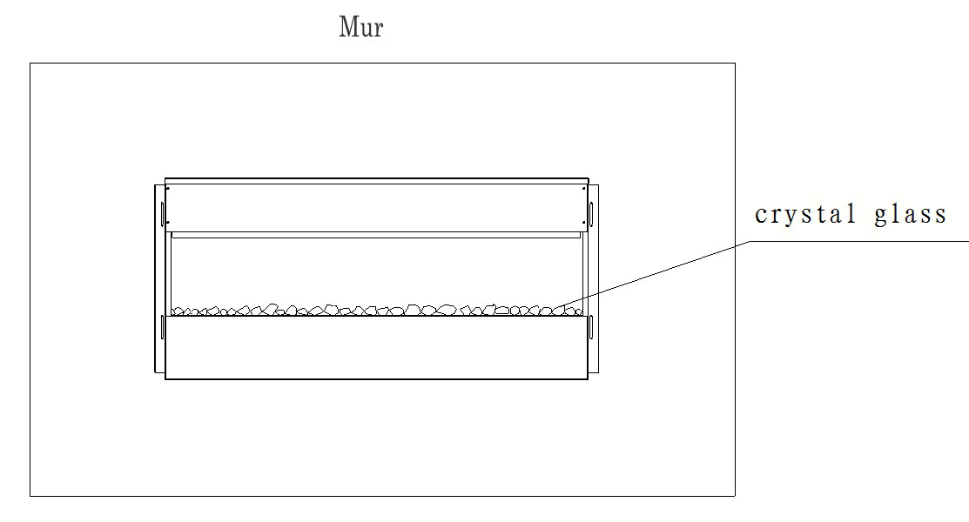

Galets
C

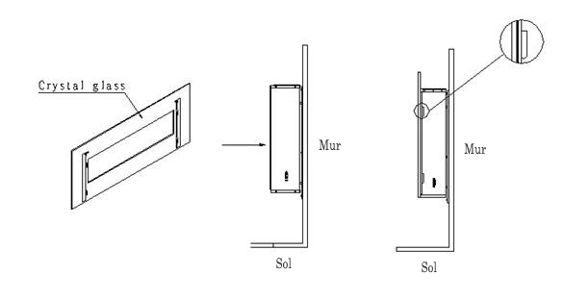
D

Galets

NOTE : Nous recommandons que cette étape soit effectuée par deux adultes.
ÉTAPE 6A. En ayant le panneau de verre soutenu par vous-même ou une autre personne, retirez les deux vis, situées sur le dessus du foyer, à l’aide d’un tournevis cruciforme (+).
ÉTAPE 6B. Ensemble, retirez le panneau de verre avec précaution et placez-le sur une surface propre et douce.
ÉTAPE 6C. Placez les galets décoratifs (F) sur le rebord du foyer, dans l’arrangement désiré. ÉTAPE 6D. Alignez les languettes du panneau de verre avec les fentes situées sur le dessus du foyer. Remettez les vis dans les trous et serrez-les à fond à l’aide d’un tournevis cruciforme.

Fonctionnement

Veuillez lire et comprendre ce guide en entier, incluant les informations relatives à la sécurité avant de brancher ou d’utiliser cet appareil. Le non-respect de cette directive peut entraîner un incendie, un choc électrique ou des blessures graves.
Alimentation
Vérifiez que l’interrupteur MARCHE/ARRÊT situé sur le côté gauche de l’appareil, est bien en position ARRÊT. Branchez le cordon électrique dans une prise murale de 120 Volts, 15 A avec mise à la terre (veuillez consulter les INFORMATIONS RELATIVES À LA SÉCURITÉ aux pages 13 et 14). Vérifiez que la prise électrique est en bon état et que la fiche est bien insérée à fond dans la prise. NE JAMAIS dépasser la puissance maximale (en ampères) du circuit. NE PAS BRANCHER d’autres appareils au même circuit.
Méthode de fonctionnement
Ce foyer électrique peut être activé par le PANNEAU DE COMMANDES situé sur le côté gauche du foyer (voir figure ci-dessous) ou par la TÉLÉCOMMANDE fournie.
L’utilisation des fonctions est la même sur le panneau de commandes et la télécommande.
Avant d’utiliser ce foyer électrique, veuillez consulter les INFORMATIONS RELATIVES À LA SÉCURITÉ en pages 13 et 14, veillez à bien respecter toutes ces directives.
NOTE | Lorsque l’appareil est mis en marche la première fois, une légère odeur peut se faire sentir. Cette odeur est normale et ne devrait pas réapparaître à nouveau, sauf si le foyer n’est pas utilisé durant une longue période de temps.

Vue avant | Vue du dessus  Évents d’air chaud  \  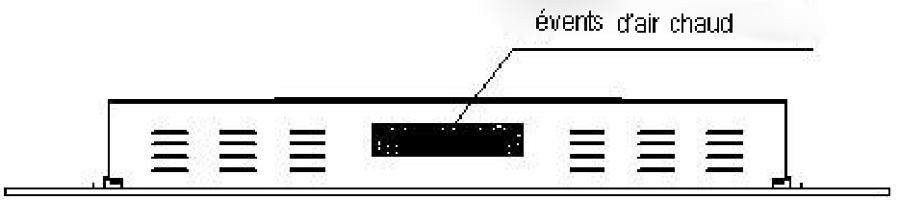

Vue arrière | Vue du côté gauche
Fonctions du panneau de commandes
BOUTON | FONCTION | ACTION ET INDICATION
MARCHE | ON (marche): Active les fonctions et la télécommande. Active l’effet de flamme.  OFF (arrêt): Arrête les fonctions et la télécommande. Arrête l’effet de flamme. | 1. Appuyer une fois. Le voyant s’allume et l’appareil se met en marche. Toutes les fonctions sont activées. .  2. Appuyer une 2e fois. L’effet de flamme s’arrête. L’unité entre en mode de veille; toutes les fonctions sont arrêtées.
MINUTERIE | Minuterie: Arrête l’appareil à une période de temps sélectionnée.  Réglage de 0,5 heure à 7,5 heures. | 1. Appuyer une fois. Le voyant s’allume. La minuterie est réglée à 0,5 heure.  2. Appuyer encore sur le bouton jusqu’à ce que le temps désiré soit atteint. Le voyant indique le réglage.
FLAMME  FLAMME - | Flamme : Réduit l’intensité de l’effet de flamme.  NOTE : L’effet de flamme demeure activé jusqu’à ce que le foyer soit à l’arrêt. L’effet de flamme doit être activé pour la chaleur. | - Appuyer une fois. L’effet de flamme changera d’intensité.  - Appuyer sur le bouton jusqu’à ce que l’intensité désirée soit obtenue.
COULEUR | Bouton COULEUR : Pour changer la couleur de l’effet de flamme.  NOTE : l’effet de couleur demeure activé jusqu’à ce que l’appareil soit arrêté. L’effet de flamme doit être activé pour que l’appareil se mette en marche. | - Appuyer une fois. L’effet de flamme changera de couleur.  - Appuyer sur le bouton jusqu’à ce que la couleur désirée soit obtenue. Un total de 10 couleurs au choix.
CHALEUR | Chaleur : Active et arrête la production de chaleur.  NOTE : Le chauffage fonctionne seulement si l’effet de flamme est activé. Si l’effet de flamme est arrêté, le chauffage ne peut être activé.  NOTE: Pour prévenir la surchauffe, le ventilateur souffle de l’air frais durant 8 à 10 secondes avant que le chauffage se mette en marche, et après qu’il soit arrêté. | 1. Appuyer une fois. Les voyants s’allument. Le ventilateur souffle de l’air frais pendant 10 secondes. Le chauffage s’active à 750W et souffle de l’air chaud.  2. Appuyer encore. Les voyants s’allument. Le chauffage s’active à 1500W et souffle de l’air chaud.  3. Appuyer encore. Le chauffage s’arrête. Le ventilateur souffle de l’air frais pendant 10 secondes pour refroidir l’appareil, puis s’arrête.

NOTE | Pour optimiser le fonctionnement, diriger la télécommande vers le récepteur de l’appareil et N’APPUYEZ PAS sur les boutons trop rapidement. Laissez à l’appareil le temps de répondre aux commandes.

Télécommande (L’interrupteur du panneau de commandes doit être à ON pour utiliser la télécommande.)

BOUTON | ACTION et INDICATION | ILLUSTRATION
MARCHE | 1. Appuyer une fois. Bip sonore. L’effet de flamme et le voyant se mettent en marche.  2. Appuyer encore. Bip sonore. Toutes les fonctions s’arrêtent. | 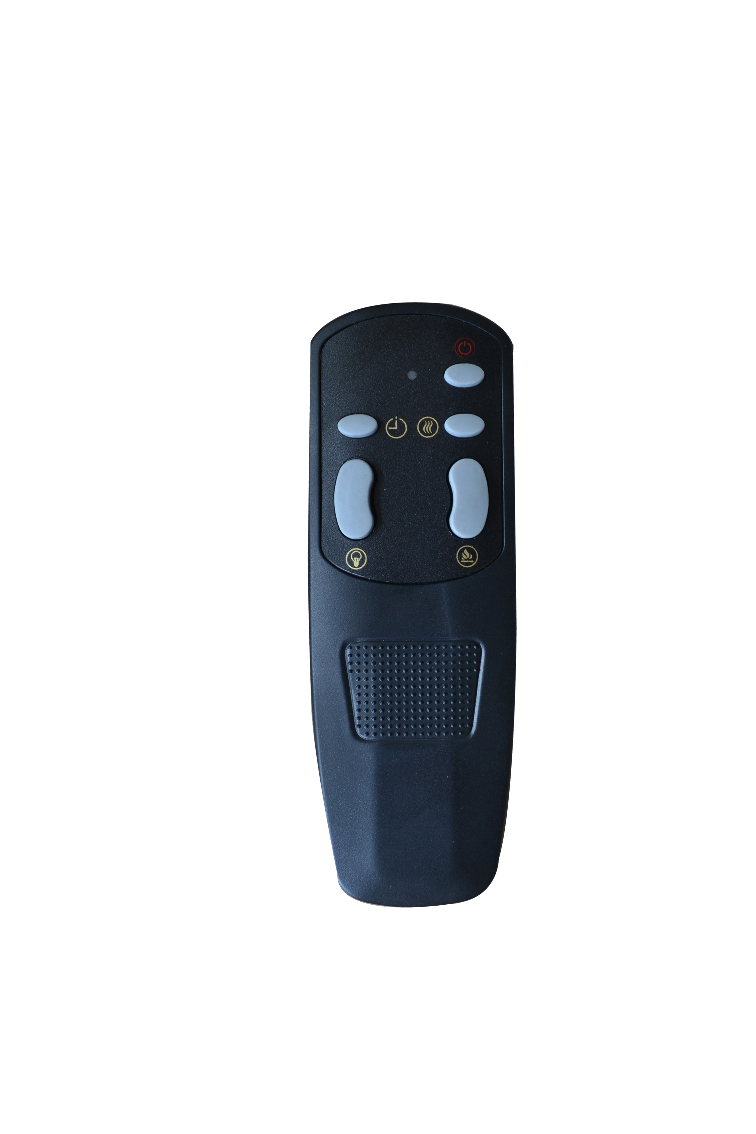
CHALEUR | 1. Appuyer une fois. Le petit voyant s’allume. Le ventilateur souffle de l’air frais. Le chauffage s’active à 750W et souffle de l’air chaud.  2. Appuyer encore. Le gros voyant s’allume. Le chauffage s’active à 1500W et souffle de l’air chaud.  3. Appuyer encore. Le chauffage s’arrête. Le ventilateur souffle de l’air frais pour refroidir l’appareil, puis s’arrête.
FLAMME | 1. Appuyer une fois. L’effet de flamme changera d’intensité.  2. Appuyer sur le bouton jusqu’à ce que l’intensité de flamme désirée soit obtenue.
COULEUR | - Appuyer une fois. L’effet de flamme changera de couleur.  - Appuyer sur le bouton jusqu’à ce que la couleur désirée soit obtenue. Un total de 10 couleurs au choix.
MINUTERIE | 1. Appuyer une fois. Le voyant 0,5 h s’allume. La minuterie est réglée à 30 minutes.  2. Appuyer encore. Le voyant 1 h s’allume. La minuterie est réglée à 1 heure.  3. Appuyer pour obtenir le réglage désiré. Le réglage de la minuterie augmente de ½ heure à chaque pression, jusqu’à 7,5 heures.  Exemples: 3 heures = 2h+1h; 7½ heures = 4h+2h+1h+½h.  4. Appuyer encore. Le réglage de la minuterie augmente de ½ heure à chaque pression, puis s’arrête.  5. Appuyer encore pour redémarrer la minuterie à 30 minutes.

NOTE | Pour optimiser le fonctionnement, diriger la télécommande vers le récepteur de l’appareil et N’APPUYEZ PAS sur les boutons trop rapidement. Laissez à l’appareil le temps de répondre aux commandes.

Limiteur de température
Cet appareil est doté d’un dispositif de contrôle de la température pour prévenir la surchauffe. Ainsi, si l’appareil atteint une température trop élevée (212°F / 100°C), il s’arrêtera automatiquement. Pour réinitialiser l’appareil :
- Débranchez l’appareil de la prise électrique.
- Mettez l’interrupteur ON/OFF du panneau de commandes à OFF. Attendez 5 minutes.
- Inspectez le foyer pour vérifier qu’aucune ouverture n’est bloquée ou pleine de poussière ou de peluches. Le cas échéant, nettoyez les ouvertures à l’aide d’un aspirateur.
- En gardant l’interrupteur principal en position d’arrêt (OFF), rebranchez l’appareil, puis remettez-le en marche.
- Si le problème se répète, faites inspecter la prise et le circuit électrique par un professionnel.

Informations relatives aux piles (télécommande)
- La télécommande utilise deux piles AAA (non incluses).
- Les instructions pour la pose des piles se retrouvent à l’intérieur du compartiment des piles de la télécommande.

NE JAMAIS jeter les piles au feu; une explosion pourrait survenir. Apportez les piles usées dans votre centre de collecte de déchets dangereux.

Entretien et nettoyage

Nettoyage
TOUJOURS arrêter et débrancher l’appareil avant l’assemblage ou le nettoyage, ou avant de le déplacer. Le non-respect de cette consigne entraînera un choc électrique, un incendie ou des blessures graves.
NE JAMAIS immerger l’appareil dans l’eau ou le vaporiser avec de l’eau. Le non-respect de cette directive peut entraîner des chocs électriques, un incendie ou des blessures graves.

Métal:
- Nettoyez les surfaces à l’aide d’un linge doux, humidifié avec un produit à base d’huile d’agrumes.
- N’UTILISEZ PAS de poli à laiton ou de détergent domestique; ces produits endommageront le fini métallique.
Verre:
- Utilisez un nettoyant pour verre de bonne qualité, vaporisé sur un linge ou un essuie-tout. Séchez à fond à l’aide d’un essuie-tout ou un linge propre et sec.
- NE JAMAIS utiliser de nettoyants abrasifs, de vaporisateurs liquides ou tout nettoyant qui pourrait rayer la surface.
Évents:
- Nettoyez la poussière, la saleté et les peluches à l’aide d’un aspirateur ou d’un linge à épousseter.

Plastique :
- Essuyez le plastique avec un linge humide et une solution d’eau et de détergent doux.
- NE JAMAIS utiliser de nettoyants abrasifs, de vaporisateurs liquides ou tout nettoyant qui pourrait rayer la surface.
Entretien
Risque de choc électrique! NE PAS OUVRIR toute composante du foyer, sauf la plaque de remplacement des ampoules. Aucune pièce réparable par l’utilisateur à l’intérieur.
TOUJOURS débrancher l’appareil avant l’assemblage ou le nettoyage, ou avant de le déplacer. Le non-respect de cette consigne entraînera un choc électrique, un incendie ou des blessures graves.
Composantes électriques et mobiles :
- Le moteur du ventilateur a été lubrifié en usine et aucun autre graissage ne sera nécessaire.
- Les composantes électriques sont entièrement intégrées au foyer et ne peuvent être réparées par le consommateur.
Entreposage:
- Rangez l’appareil dans un endroit propre et sec lorsqu’il n’est pas utilisé.

