Oscillating Ceramic Tower Heater
Owner’s Manual
Model: FH130

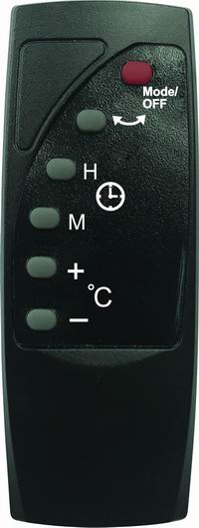
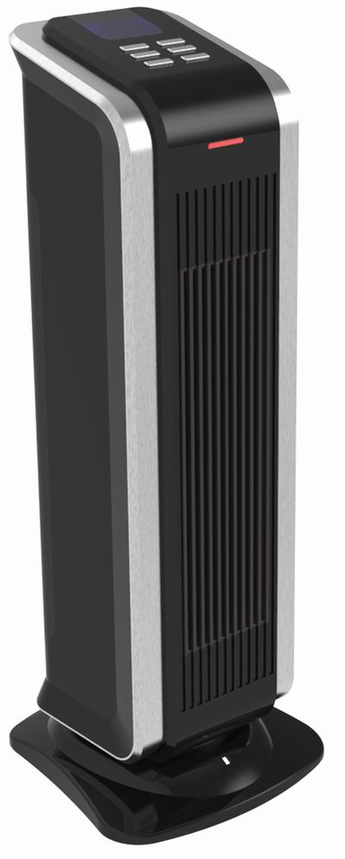

PLEASE READ AND SAVE THESE IMPORTANT SAFETY INSTRUCTIONS
IMPORTANT INSTRUCTIONS
PLEASE READ ALL INSTRUCTIONS BEFORE USING THIS HEATER.
WHEN USING ELECTRICAL APPLIANCES, BASIC PRECAUTIONS SHOULD ALWAYS BE FOLLOWED TO REDUCE THE RISK OF FIRE, ELECTRIC SHOCK AND PERSONAL INJURY, INCLUDING THE FOLLOWING:

When switching on the appliance for the first time, allow it to run at full power for about two hours to get rid of the unpleasant smell. Make sure that the room in which the appliance is located is well ventilated during this operation. It is normal for the appliance to emit small cracking sounds when you turn it on if the first time.

- Read all instructions before using this heater.
- This heater is hot when in use. To avoid burns, do not let bare skin touch hot surfaces. Use handle when moving the unit. Keep flammable materials such as furniture, pillows, bedding, papers, clothes, and curtains at least 3 feet (0.9 m) from the front and top of the heater and keep them away from the sides and rear of the heater. Keep the rear grille away from walls or drapes so as not to block the air intake.
- Extreme caution and supervision is necessary when any heater is used near children or invalids and whenever the heater is left operating and unattended.
- Always unplug heater when not in use.
- Do not use any heater with a damaged cord or plug or after the heater malfunctions or has been dropped or damaged in any manner. Discard heater or return to an authorized service facility for examination and/or repair.
- Do not use outdoors.
- This heater is not intended for use in bathrooms, laundry areas or other similar indoor locations. Never locate heater where it may fall into a bathtub or other water container.
- Do not run cord under carpeting. Do not cover cord with throw rugs, runners, or similar coverings. Do not route cord under furniture or appliances. Arrange cord away from traffic areas and place it where it will not be tripped over.
- To disconnect heater, turn controls to off, then remove plug from outlet.
- This appliance has a polarized plug (one blade is wider than the other). This plug is intended to fit a polarized outlet only one way. If the plug does not fit fully in the outlet, reverse the plug. If it still does not fit, consult a qualified electrician. Do not connect the heater to extension cords, surge protectors, timers, direct breakers, or an outlet with other appliances connected to the same outlet. Risk of fire, overheat, malfunction, property damage, injury, or even death may result if not adhered to!
- Connect to properly polarized outlets only.
- Do not insert or allow foreign objects to enter ventilation or exhaust openings, as this may cause an electric shock or fire, or damage the heater.
- To prevent a possible fire, do not block air intakes or exhaust in any manner. Do not use on soft surfaces, like a bed, where openings may become blocked.

- A heater has hot and arcing or sparking parts inside. Do not use it in areas where gasoline, paint, or flammable liquids are used or stored.
- Use this heater only as described in this manual. Any other use not recommended by the manufacturer may cause fire, electric shock, injury to persons or other damage to property.
- This heater must be plugged into a 120V, 15-amp (or more) circuit of its own. Nothing else can be plugged into the same circuit. If unsure if your home meets this specification, consult a certified electrician prior to use. Risk of fire, overheat, malfunction, property damage, injury, or even death may result if not adhered to!
- To prevent overload and blown fuses, be sure that no other appliance is plugged into the same outlet or into another outlet wired into the same circuit.
- It is normal for the heater’s plug and cord to feel warm to the touch. A plug or cord that becomes hot to the touch or becomes distorted in shape may be a result of a worn electrical outlet. Worn outlets or receptacles should be replaced prior to further use of the heater. Plugging heater into a worn outlet/receptacle may result in overheating of the power cord or fire.
- Ensure the heater is on a stable, secure surface to eliminate the potential of tipping over.
- Always plug heaters directly into a wall outlet/receptacle. Never use with an extension cord or relocatable power tap (outlet /power strip).
- Be sure that the plug is fully inserted into appropriate receptacle. Please remember that receptacles also deteriorate due to aging and continuous use: check periodically for signs of overheating or deformations evidenced by the plug. Do not use the receptacle and CALL your electrician.
- Check that neither the appliance nor the power cable has been damaged in any way during transportation.
- Make sure that no pieces of polystyrene or other packaging material have been left between elements of the appliance. It may be necessary to pass over the appliance with a vacuum cleaner.
- This appliance is not intended for use by persons (including children) with reduced physical, sensory or mental capabilities, or lack of experience and knowledge, unless they have been given supervision or instruction concerning use of the appliance by a person responsible for their safety. Children should be supervised to ensure that they do not play with the appliance.

CAUTION: To prevent electric shock, match wide blade of plug to wide slot and fully insert.

SAVE THESE INSTRUCTIONS

PET OWNERS WARNING:
The health of some small pets including birds are extremely sensitive to the fumes produced during the first-time use of many appliances. These fumes are not harmful to humans but we recommended that you do not use your heater around birds and small pets during its initial use until the manufacturing corrosion coatings burn off.

PARTS LIST

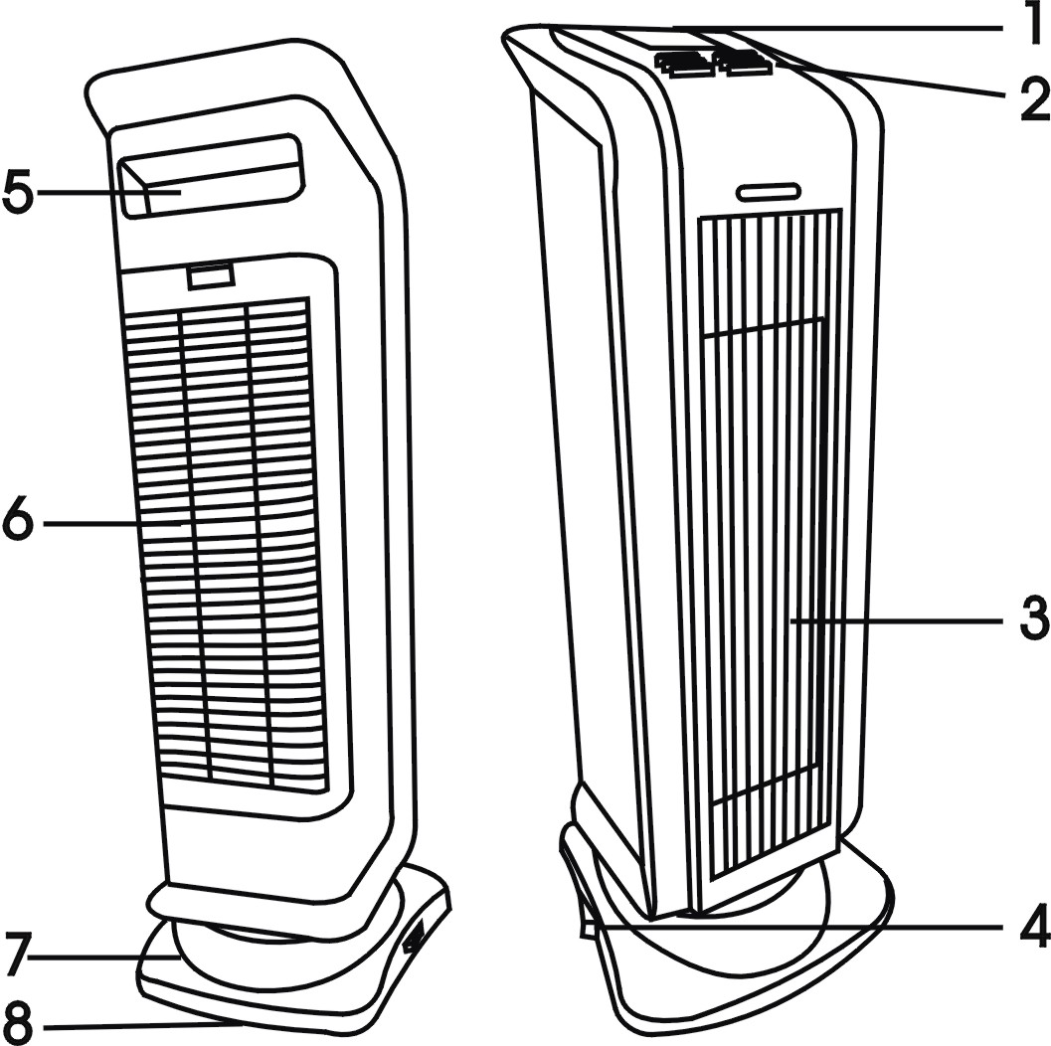
1. Digital LCD screen
2. Operation buttons
3. Air flow outlet
4. Power switch
5. Handle
6. Air inlet (filter net)
7. Base
8. Tip-over switch

OPERATION INSTRUCTIONS

1. Be sure to plug the heater into a 120V AC, 60Hz outlet. Check that the plug and the socket fit well, then you can operate the appliance.
2. The appliance has a POWER SWITCH located at the base of the unit. Press the switch to "I" to switch heater on, and "O" to switch off.
3. The heater can be operated manually or by remote control. When using the remote control, first insert AAA type batteries into the back of the remote, following polarity. Point remote control transmitter towards receiver to operate. If the heater does not respond to the remote control, the batteries likely require replacement.

Fig.1 Digital LCD screen
Symbol  1. Osc  2. Auto  3.  4.   5. 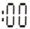  6. 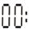  7.  8. Room temperature  9. Set temperature | Function  1. Oscillating  2. Automatic heating mode  3. Low heat (750 W)  4. High heat (1500 W)  5. Minute setting (timer)  6. Hour setting (Timer)  7. Timer function | 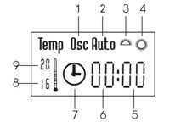

Fig.2 Operation buttons and Remote controller
Symbol  MODE/OFF | Function  Oscillating  Power on/off & Mode  Timer function  ("H" for hour setting & "M" for minute setting)  Temperature setting  ("+" to increase / "-" to decrease set temperature) | 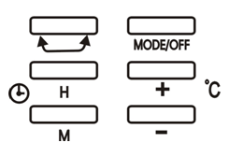  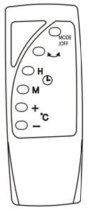

4. You can use the heater according to the different functions on the control panel or the remote, as described above.
4.1 Press the “MODE/OFF” button repeatedly to select low heating (), high heating (), or auto-heating mode (Auto), or to power off the heater after 15 seconds.
Note: When heating, the set temperature must be higher than the room temperature. If the set temperature is lower than the ambient temperature, the unit will blow cool air only.

4.2 When the unit goes in Auto mode, the heater will work at low power (750W) when the room temperature is lower than the set temperature by 2ºC, or higher than the set temperature by 1ºC.
When the room temperature is higher than the set temperature by more than 1ºC, the unit will blow cool air only.
The heater will work at high power (1500W) when the room temperature is lower than the set temperature by 3ºC or more.

4.3 Temperature setting:
Press the buttons "+" and "-" to increase or decrease the set temperature, within a setting range of 6ºC to 38 ºC.
Note: When the heater is first switched on, the default temperature (20 ºC) will display on the LCD.

4.4 Timer setting:
Press the timer buttons "H" and "M" to select the timer off range, between 1 and 24 hours.
"H" range is 1~23 hours and "M" range is 0~59 minutes. When the timer has been set, the "" symbol will be lit on the LCD display.
Once the timer is set, the remaining time until the heater is switched off will change on the LCD as the time passes.

4.5 Press the "" button to make the unit oscillate. The oscillation symbol "Osc" will be lit on the display. Press the button again to stop oscillating.

PROTECTION SYSTEMS

OVERHEAT PROTECTION
This heater includes an overheat protection system that shuts the unit off when parts of the heater overheat. If this occurs, turn the heater off, unplug it, and inspect and remove any objects on or adjacent to the heater that may cause high temperatures. Wait 10 to 20 minutes for the unit to cool down. Then plug it back in, and resume the normal operation.

TIP-OVER SWITCH
Your heater is equipped with a tip-over switch, which is designed to automatically shut off unit when tipped forward or backwards. When returned to normal upright position, the heater will automatically come on again. This is a safety to avoid the possibility of fire should the unit be accidentally tipped over.

CLEANING AND MAINTENANCE

- Before any cleaning, make sure that:
  - The heater is turned OFF.
  - Disconnect power supply at source by removing plug from power outlet.
- Regular cleaning:
  - Interior dust can often be removed by using a vacuum cleaner with a crevice tool attachment.
  - Do not use cleaning spray-on liquids or other chemicals on the unit
  - To clean enclosure, use a clean, soft and lightly damp cloth to gently wipe off the dirt from the surface of the unit. Be sure not to wet the heating element and the switches. Allow the unit to dry completely before using it.

CAUTION: DO NOT ALLOW WATER TO RUN INTO THE INTERIOR OF THE HEATER AS THIS COULD CREATE A FIRE OR ELECTRIC SHOCK HAZARD.

STORAGE

- Perform the cleaning procedures described in “CLEANING AND MAINTENANCE” section.
- Wipe all parts to dry.
- Pack the heater in a plastic bag and store it in a cool, dry place.
TROUBLESHOOTING

If your heater fails to operate, please follow these procedures prior to contacting Customer Service:
Problem | Probable Cause | Solution
Heater will not power on | Heater is not plugged into a 120V polarized outlet / receptacle. | Ensure unit is in OFF position. Plug in unit and attempt to turn on again.
Heater will not power on | Breaker / fuse has been  tripped. | Please check your electrical box to confirm the breaker has not been blown. This may occur if the unit is sharing a receptacle with another high power consuming appliance. Ensure unit is in OFF position. Plug in unit and attempt to turn on again.  Attempt to plug unit into another independent circuit in the house.
The power indicator light is illuminated, but no heat disperses from the unit | Room temperature has been warmed up to thermostat setting. | To resume heating, adjust thermostat temperature to a higher setting. Refer to THERMOSTAT section on page 4 for more information.
The heater produces  a burning smell. | A drop of oil fell on the heating coil during the manufacturing process. It will quickly evaporate and should not occur again. | Ensure room in which heater is located is well ventilated.
The heater produces  a burning smell. | Check & ensure there are no combustible materials  within 3' (0.9 m) of the heater. | Remove the combustible materials preventing air intake into the heater.

PLEASE DO NOT ATTEMPT TO OPEN OR REPAIR THE HEATER YOURSELF, DOING SO COULD VOID THE WARRANTY AND CAUSE DAMAGE OR PERSONAL INJURY.

