ELECTRIC FAN
INSTRUCTION MANUAL
MODEL NO. CRWF-1601(E)

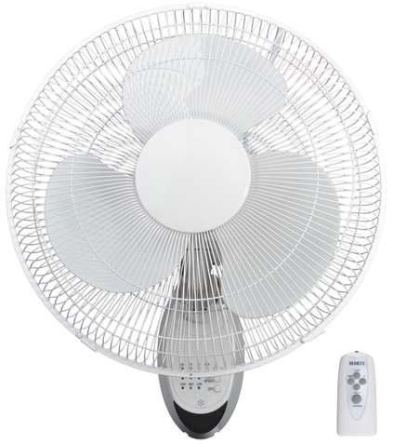

Customer Service: service@hena.ca

Thank you for purchasing this electric fan. Please read this manual carefully before using the
Fan and keep this manual in a safe place for future reference.

1) GENERAL SAFETY RULES
- Read and save these instructions.
- Do not connect the fan to the power supply until the fan is FULLY assembled.
- Do not connect to any power supply other than 120V/60Hz.
- Never operate the fan if it has damaged or worn parts. In such case, it should be returned to the manufacturer, service agent or a similarly qualified person for repair to avoid a hazard.
- Always position the fan on a stable, level surface.
- Do not spray anything into the fan.
- Do not use the fan near flammable areas or substances.
- To reduce the risk of electric shock, do not remove any screws.
- Do not insert fingers or other objects through the fan guard.
- Do not remain in the direct wind path of the fan for long periods of time.
- The appliance is designed for indoor use only.
This appliance can be used by children aged from 8 years and above and persons with reduced physical, sensory or mental capabilities or lack of experience and knowledge if they have been given supervision or instruction concerning use of the appliance in a safe way and understand the hazards involved. Children shall not play with the appliance. Cleaning and user maintenance shall not be made by children unless they are older than 8 and supervised.
Keep the appliance and its cord out of reach of children younger than 8 years old.

MAINTENANCE：
- Unplug the appliance from the power before servicing and cleaning.
- Clean the fan enclosure and rotor blade guard with a slightly damp cloth and dry it with a dry cloth.
- If the supply cord is damaged, it must be replaced by the manufacturer, its service agent or similarly qualified persons to avoid a hazard.
- Do not remove blade guard after initial assembly.
- The rotor guard shall not be dissembled or opened to clean the rotor blades.

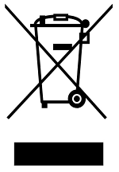 | Disposal: Do not dispose of electrical appliances as unsorted municipal waste; use separate collection facilities. Contact your local authority for information regarding the collection systems available. If electrical appliances are disposed of in landfills or dumps, hazardous substances can leak into the groundwater and get into the food chain, damaging your health and well-being.

2) SPECIFICATIONS
Model | Rated Voltage | Rated Frequency | Rated Power
CRWF-1601 (E) | 120V | 60Hz | 45W

3) PARTS LIST

- Front Grille
- Blade Retaining Cover
- Fan Blades
- Nut
- Rear Grille
- Bolt
- Shaft
- Motor Head
- Motor Housing
- Electric Plug & Cord
- Screw
- Hanging Panel
- Fan Angle Adjustment
- Remote Control

4) ASSEMBLY INSTRUCTIONS
1. Unscrew the grille nut (4) and place the rear grille (5) onto the motor head (8). Tighten the nut in a clockwise direction to attach the rear grille.
2. Place the fan blades (3) onto the motor shaft (7), making sure to align the shaft bolt (6) into the fan slots (2 slots). Tighten on the blade retaining cover (2) in a counter-clockwise direction.
3. Place the front grille (1) onto the rear grille (5) and attach using the guard retaining clips; tighten the nut to secure the grilles together.
4. The hanging panel (12) has two keyhole slots in the back bracket for mounting on a wall.
5. For wall mounting, drill four pilot holes and insert four wall plugs in the wall (if required). Install bracket to the wall with four suitable screws (not supplied).
- Slide hanging panel down into the wall bracket to install fan into place.

5) OPERATION INSTRUCTIONS
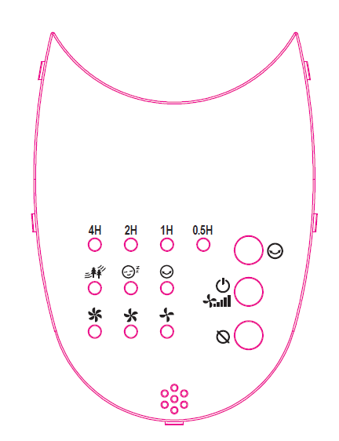
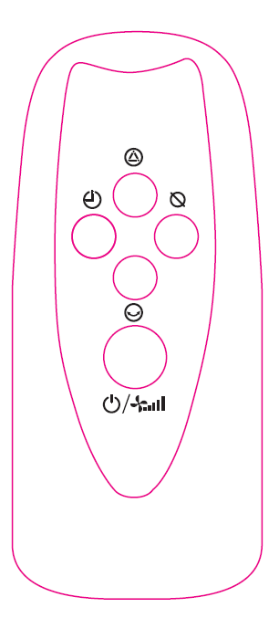

Control Panel Remote Control

Once the fan has been completely assembled, plug the fan into a suitable outlet, then switch power on. The fan can be operated by the control panel or the remote control.
1. ON/SPEED: Button shows as . The fan has 3 speeds: low speed (1), medium speed (2), high speed (3). ‘LOW’, ‘MED’, ‘HIGH’ will be displayed on the control panel.
2. TIMER (all functions will automatically stop when setting the timer): the timer can be set from 0.5 to 7.5 hours. Press the TIMER button each time to add 0.5 hour to the timer. On the remote control, settings “4h, 2h, 1h, 0.5h” light up accordingly showing the desired timer setting.
3. MODE: this unit has two ventilation modes: sleeping and natural mode. The indicators NATURAL or SLEEP appear on the control panel. Press the MODE button to select one or the other mode. On the remote control, the corresponding indicator lights up accordingly.
4. SWING: Pressing the SWING button to make the fan oscillate from side to side. Press this button again will stop the oscillation.
5. OFF: Press the OFF button to turn off the fan.

