30cm DESK FAN

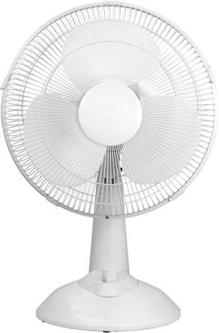

Instruction Manual

Model: CRDF-12A

Important Safeguards

When using electrical appliances, in order to reduce the risk of fire, electric shock and/or injury, these basic safety precautions should always be followed:

For Your Safety

Read all instructions carefully, even if you are quite familiar with the appliance.

- This appliance is not intended for use by persons (including children) with reduced physical, sensory and mental capabilities, or lack of experience and knowledge, unless they have been given supervision or instruction concerning use of the appliance by a person responsible for their safety.

- Children should be supervised to ensure that they do not play with the appliance.

- Switch off the power outlet and remove the plug when the appliance is not in use.

- Do not operate any appliance with a damaged power cord or plug; if the appliance malfunctions; or if it is dropped or damaged in any manner.

- Do not use outdoors.

- Do not use any appliance for anything other than its intended use. This product is intended for household use only.

- This appliance is intended to be plugged in a 240V power outlet only.

- Do not misuse the power cord. Never carry the appliance by the power cord or pull to
disconnect it from the outlet. Instead, grasp the plug and pull to disconnect.

- Do not attempt to repair, disassemble or modify the appliance. There are no user-serviceable parts.

- Arrange the power cord away from traffic areas where it will not be tripped over.

- Do not insert or allow foreign objects to enter the grille openings as this may cause damage to the appliance and/or injury to the user.

- Do not place the fan close to an open window. Rain splashing on the fan could cause an electric shock hazard.

- Ensure that the fan is switched off from the supply mains before removing the guard.

Warning

If the supply power cord is damaged, the power cord must be replaced by the manufacturer, its service agent or similarly qualified persons in order to avoid a hazard.

This product has not been designed for any uses other than those specified in this booklet.

Save These
Instructions

Features of Your Desk Fan

Fixed or Oscillating

Control Clutch
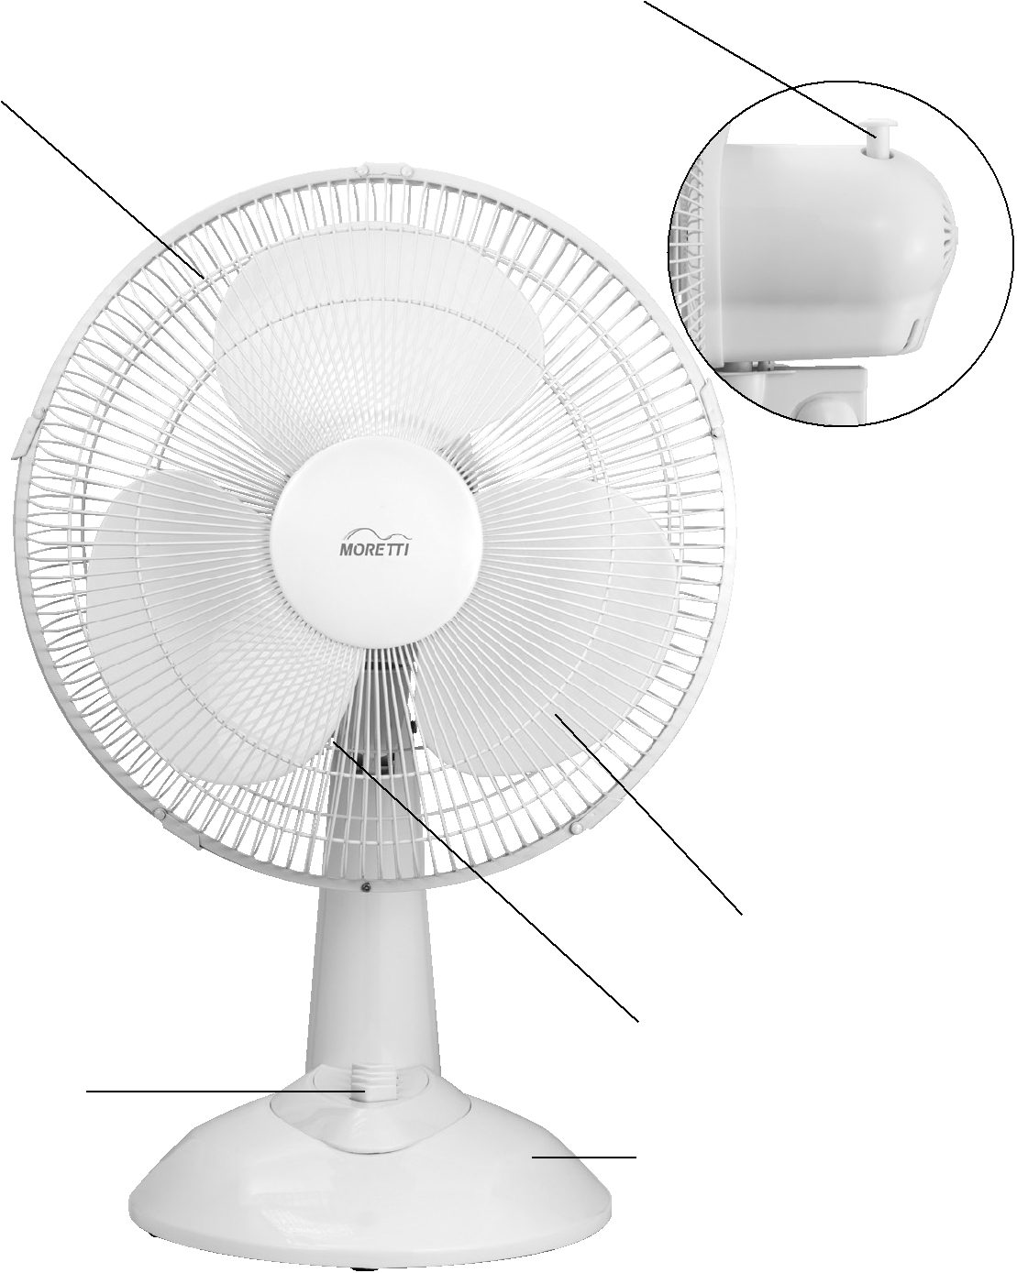
Safety Grille

Blade Assembly (inside)

Tilt Adjustable Knob

3 Speed Push Button Control

Anti-Topple Base

Using your Desk Fan

Congratulations on the purchase of your new Desk Fan.

Before first using your new Desk Fan, it is most important that you read and follow the instructions in this use and care booklet, even if you feel you are familiar with this type of appliance.

Your attention is drawn particularly to the section dealing with IMPORTANT SAFEGUARDS. Find a safe and convenient place to keep this booklet handy for future reference.

This appliance has been designed to operate from a standard domestic power outlet. It is not intended for industrial or commercial use.

Your Desk Fan is safe and easy to use. It has been designed to function quietly and safely under normal circumstances. Your Desk Fan is fully portable with a sturdy stand and contemporary design. Its efficient blades circulate cool air. The heavy-duty motor is rated for continuous use to combat long hot summers.

Use the control clutch to choose fixed direction for personal comfort or oscillating to cover larger areas.
Assembly of Your Desk
Fan

Your Desk Fan has been boxed unassembled to minimise packaging waste. Each part is designed to fit together and be disassembled easily for cleaning or storage.

Insert stand pole into base, fix them with 8 screws provided(Fig. 1)
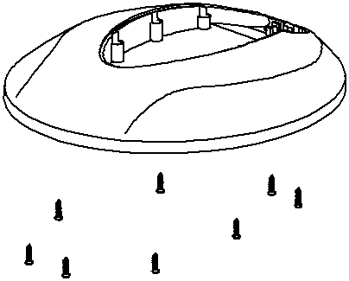

Fig. 1

To assemble the safety grille and blade assembly.

Position the rear grille against the front of the motor housing with the hole for installing safety screw downward, and ensuring that the locating lugs on motor housing are engaged correctly in the holes of the rear grill.

Fix the safety grille into position by assembling the locking nut tightly by hand (Fig 2). Do not force the locking nut.
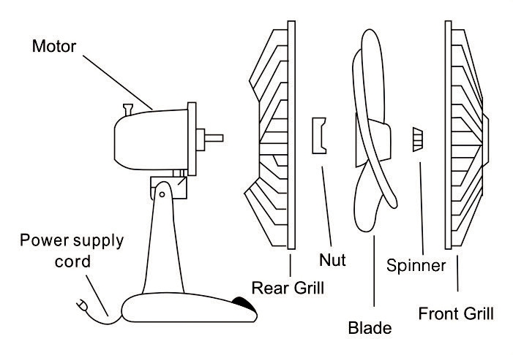

Fig. 2

The groove in the centre of the fan blade aligns with a T-bar on the motor spindle to ensure correct positioning.

Fix the blade into place by gently hand tightening the spinner (Fig. 2) counter clockwise onto the end of the motor spindle. The spinner is selftightening; do not force it.
Screw the vane into the front safety grille with the screw by cross screwdrive.

Lift out all locking clips on the front safety grille (Fig. 3).
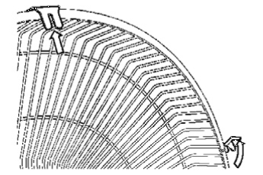

Fig. 3

Place the safety grille into position and secure it by fastening the clips over the outer rim. The screw and nut at the bottom of the grille must be fitted (Fig. 4).
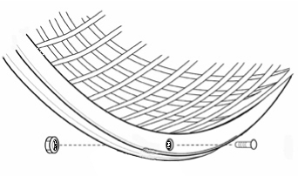

Fig. 4
Operation of Your Desk
Fan

Remove the cable tie and unravel the cordset before operation.

Loosen the tilt adjustable knob, tilt up or down until the desired position is located, and then secure the tilt adjustable knob by fastening it (Fig.5).
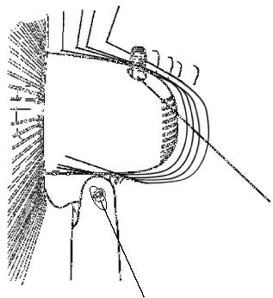

Clutch

Tilt Adjustable Knob

Fig. 5

Press button 1 for a low speed, 2 for a medium speed and 3 for a high speed. Press 0 to switch the Desk Fan off.

To blow air in one direction and stop oscillation, allow the Desk Fan to move into the desired position and pull the clutch knob up. To return to a normal oscillating function, press the clutch knob down.

Care and Cleaning

Always disconnect electrical appliances before cleaning them.

To clean the blade and grille assembly, first remove the safety grille, remove the blade from the Desk Fan. Wipe them clean with a slightly damp sponge.

Clean the motor housing and body assembly with a clean, damp cloth and wipe dry.

Never spray the Desk Fan with liquids or submerge it in water or any other liquid.

